FORMAL ACADEMIC

* TK SERUNI, MAJALENGKA
* SD NEGERI 2 SUTAWANGI, MAJALENGKA
* SMP ITUS JALAKSANA, KUNINGAN
* SMA NEGERI 1 JATIWANGI, MAJALENGKA
* UNIVERSITAS PADJADJARAN (JURUSAN TEKNIK PERTANIAN), BANDUNG

NON FORMAL ACADEMIC

PRAKTEK KERJA LAPANG (SISTEM MANAJEMEN PANEN DAN PASCA PANEN TANDAN BUAH SEGAR KELAPA SAWIT) DI PT. CONDONG GARUT

KULIAH KERJA NYATA DI LEUWILIANG BARU, MAJALENGKA

PELATIHAN SOFTWARE AUTOCAD UNTUK GAMBAR RANCANG BANGUN LOMBA RANCANG BANGUN

PELATIHAN PKM 5 BIDANG

LEMBAGA KAMMI MUSLIM (DIVISI SOSIAL KEMASYARAKATAN) PEMILIHAN RAYA MAHASISWA UNPAD PPF

MAGANG DI HIMPUNAN MAHASISWA TEKNIK PERTANIAN DIVISI KEPROFESIAN

FTIP FAIR DIVISI DEKORASI

SEMINAR “CAREER DEVELOVMENT CENTER-COMMUNICATION SKILL”

SJAKJSAJSKJAKSJAS

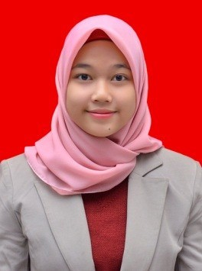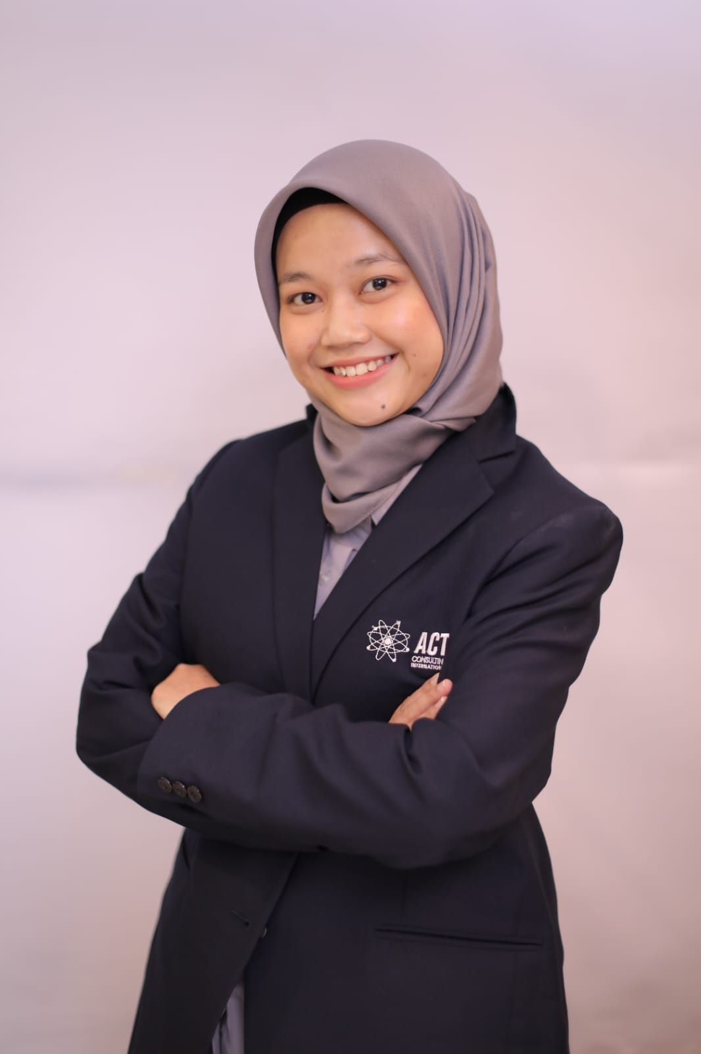

ENDAH DIVA QANIAPUTRI

BANDUNG, 29 JULI 1995

# INTRODUCTION

Hallo! I'm Endah and I love field work. I like Field Assistant Position. I am able to interact easily. I am diligent and happy to do new things.

# PROFESSIONAL SKILLS

- Computer (MS Word, MS Excel, MS Power Point, MS Access)

- Indonesia and English Language

- Internet

- Design and Creative Team

- Corel Draw

# CONTACT DETAILS

Number: 089503336608

Email: [e.d.qaniaputri2907@gmail.com](mailto:e.d.qaniaputri2907@gmail.com) Instagram: envaqp

Address: Jln. Letda Angkat Arzain No. 26 RT/RW 01/14 Majalengka - Jawa Barat

* Proofreading buku AKHLAK BUMN (ESQ)
* Proofreading buku Vaksin Hati
* Editor Buku BI Religi
* Proofreading Rakorwil Solo dan Kaltim
* Dll

# MY INTERESTS

Reading and Writing Article Hiking

Travelling Culinary Design Editing Photography

Organize file and other items