**RESUME**

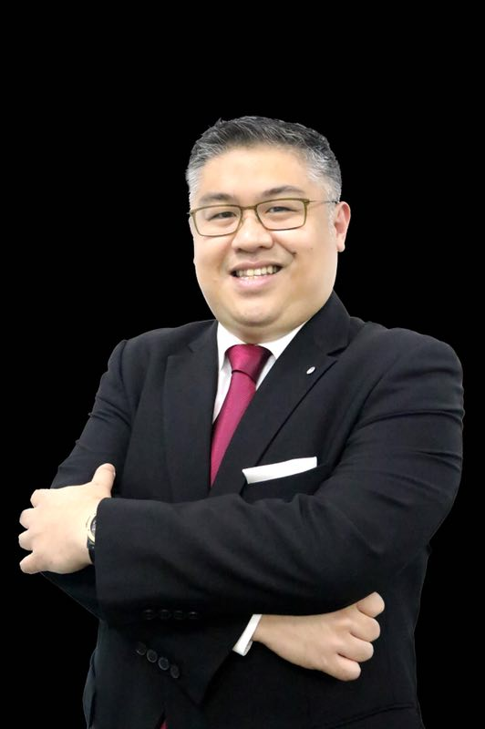

**Mr VINCENT YAP KOK LEONG**

Date of Birth – 31st May 1976

Nationality- Malaysian

Marital Status- Single

Height - 1.73 m

Weight- 95 kg

Race- Chinese ( mother tongue Cantonese )

Language Spoken and Written- Fluent English, Mandarin & Cantonese

**Education-**

Higher Diploma in Hotel Management (SHATEC) with the endorsement of Lausanne

Cambridge G.C.E ‘A’ Levels with Distinction in Management of Business

Hyatt Food & Beverage Management Development Program

IHG Revenue Management Intermediate Course Certified

Hyatt Selling Techniques Certified

Hyatt Train the Trainer Certified

Hyatt Integrated Marketing & Communication Star award

Wine & Spirits Education Trust 2 Certified BY SOPEXA

Email- [vincentyap9@hotmail.com](mailto:vincentyap9@hotmail.com)

Contact- +6012 2952566 whatsapp

[linkedin.com/in/vincent-yap-49500b22](https://www.linkedin.com/in/vincent-yap-49500b22?lipi=urn%3Ali%3Apage%3Ad_flagship3_profile_view_base_contact_details%3BxwAVOJyzQDOwgIlRLwOByw%3D%3D)

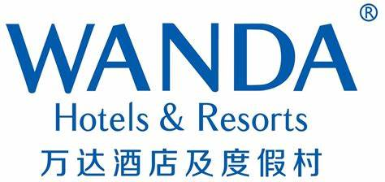

**[Hotel General Manager-](https://www.linkedin.com/company/340686/)**

[Wanda Vista Istanbul](https://www.linkedin.com/company/340686/) **[(Luxury & Upscale)](https://www.linkedin.com/company/340686/)**

[April 2022 – present](https://www.linkedin.com/company/340686/)

[Istanbul, Turkiye](https://www.linkedin.com/company/340686/)

Representing Wanda Hotel Group to manage the one and only Wanda Hotel & Residence property outside China. A joint partnership between China largest Real Estate company Wanda Group and renowned Turkish Real Estate developer MARYAPI 125 rooms Hotel and 325 rooms Residence property situated in the new developing district of Bagcilar in Istanbul, Turkiye  
Mission- Maintain balance between Wanda Brand Standards ,Owners Interest, Guest Experience and Employee Morale.

**Achievements-** Successfully re positioned the Hotel property after COVİD 19 pandemic to achieved set targets in less than 6 months. By working on the 6 Ps

Positioning, Products, People, Packaging, Process, Promotion with a sense of Purpose and Passion

Driven the team to achieve a substantial increase in GOR by over 45% in 2023 1st Half compared to 2022. Year to date GOP at 50% dated July 2023

Won over the owners’ trust and confidence in Wanda Brand as the financial numbers have positively grown just after 8 months into hotel opening.

Developed Chinese Elements in the hotel including a Chinese restaurant which has spur the Chinese nationality market segment from 15% to 30% of total Guest demographic

With the right strategies and product alignment, F&B have seen a positive growth in guest count by over 40% in first 6 months 2023 compared to 2022.

Led the team to focus and driven the social media scores on most platforms to increase scores such as Trip.com, Booking.com , Expedia and Agoda.

Together with the team, we got the Wanda Vista Hotel to get the 5 STAR Hotel certification in September 2022. The hotel was audited , certified and awarded by the Ministry of Tourism of Turkiye

**[Hotel Manager- Dual Property](https://www.linkedin.com/company/340686/)** [( On GM Ready posting list )](https://www.linkedin.com/company/340686/)

[Wanda Vista & Realm Resort Songbei, Harbin](https://www.linkedin.com/company/340686/) **[(Luxury & Upscale)](https://www.linkedin.com/company/340686/)**

[Aug 2018 – Dec 2020](https://www.linkedin.com/company/340686/)

[Harbin, Heilongjiang, China](https://www.linkedin.com/company/340686/)

Reporting to my Cluster GM, I am responsible for the entire operations and business of a252 rooms and suites Wanda Vista Hotel & a 395 rooms Wanda Realm Resort property adjacent to one another situated within Harbin Wanda City. Total 6 outlets and huge banqueting facilities with an unrivaled 1800 sqm Grand Ballroom. The World largest indoor ice ski entertainment theme park & Wanda Mall are just a walking distance away from this dual properties. Leisure and MICE market are two predominant business segments in this Ice city of Harbin.

**Achievements-**

**ROOMS-** Led and driven the young team to pass our LRA audits score 89.9 for Vista and 91.4 for Realm. GEI score for 2018 at 89 for Vista and 86 for Realm. Exceptional Social Media Scores both at 96. LRA score 2019 Vista at 91.5 and Realm at 94.2

**Food & Beverage** – Expanded revenue share of outlets and banquets from 48% to 52% through product quality improvement and relevant promotional strategies.

**Hotel Manager role to support S&M**- Enhanced operational effectiveness so as to facilitate S&M to achieve set targets

Collaborated Sales team to increase their conversion ratio through better training and guide

**Others—**Accomplished reduction in LOST business through enriching better communication among the team and with potential business contacts

Capitalized on all potential business opportunities within hotel property and through external networking thus having annual Gross Operating Revenue to surpass 100 million rmb mark

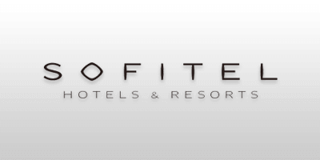

**[Hotel Manager](https://www.linkedin.com/company/340686/)**

[Sofitel Foshan](https://www.linkedin.com/company/340686/)

[Sep 2017 – Jun 2018](https://www.linkedin.com/company/340686/)

[Foshan, Guangdong, China](https://www.linkedin.com/company/340686/)

A Flagship SOFITEL Property in Southern China situated in the world largest furniture city of Lecong featuring French heritage hospitality & Local Cantonese Culinary offerings. Ensuring consistently high quality products & services via a Hotel Operator to achieve the right market segments & Average Daily Room Rate is 1st goal on the list for both the owner and the SOFITEL brand

**Achievements-**

In the absence of a GM for 5 months , I have driven and still driving the hotel’s sales team to achieve ranking number 2 in Revenue Generation Index (RGI) against among 5 international hotels in the COMPSET year to date April 2018. (RGI ranked number 1 in March 2018)

Guest satisfaction index were among top 3 in ACCOR Greater China under luxury & upscale category with average of 93% for 2018 1st quarter.

With much efforts and drive, I managed to increase GOP percentage to a desirable percentage for a 9 months old property.

F&B revenue constitutes 55% of total hotel revenue with sound strategies and tactics to revamp F&B products to be more relevant to local market straight after opening in the 4th month

Guided and drive the sales team to increase conversion ratio against all sales leads with record breaking first 10 million revenue in December 2017 and second surpass 10 million revenue marked in March 2018.

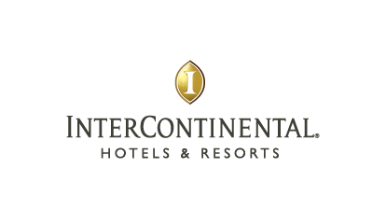

**[Resident Manager](https://www.linkedin.com/company/2784733/)**

[InterContinental Kunming](https://www.linkedin.com/company/2784733/)

[Nov 2015 – Jul 2017 ( 1 year 9 months)](https://www.linkedin.com/company/2784733/)

[Kunming, Yunnan, China](https://www.linkedin.com/company/2784733/)

Best urban resort hotel in Kunming with 541 rooms adjacent to Haigeng Government Meeting Hall offering unrivaled products and facilities. Driving targeted RGI and Revpar besides a 200 million annual revenue budget were some key performance indicators.

**Achievements-**

Under the mentoring and coaching of veteran Cluster GM Mr Roland Steiner (40 years with IHG), we brought the hotel’s revenue to new heights with a record of close to 200 million rmb revenue in year 2016 and GOP of 42%

RGI was well maintained on number one spot in STR for consecutive months in the year with increase of index of 110 to 126 on average.

Achieved average 85 points and above for Food Safety (FSMS) audits, 100 % Risk Management audit, 95% Fire Life Safety audit and 87% for Engineering audits.

I was key operational in charge for various successful Government events in which the property was protocol oriented hosting venue due to the proximity of the Haigeng Government Meeting Hall of the People’s Communist Congress Party

**[DGM](https://www.linkedin.com/company/2784733/)**

[InterContinental Suzhou](https://www.linkedin.com/company/2784733/)

[Oct 2014 – Nov 2015 (1 year 1 month)](https://www.linkedin.com/company/2784733/)

[Suzhou, Jiangsu, China](https://www.linkedin.com/company/2784733/)

Recognized as the Best Business Hotel in Suzhou with 420 rooms and a talk of the town Steak house in Suzhou next to Jin Ji Lake. Developed "Representing Local Chinese hotel owner" management skill during this period which is both daunting & worthwhile. Think Local, Act Global can be dual but yet conflicting at times.

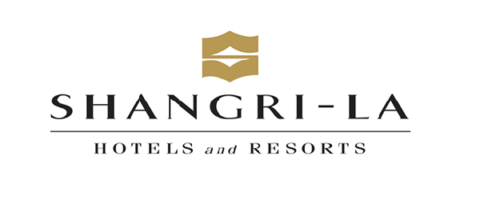

**Director of Food & Beverage**

Shangri-La Hotels and Resorts

Apr 2013 – Oct 2014 (1 year 7 months)

Qingdao, Shandong, China

Best MICE hotel in Qingdao with 700 rooms , huge banqueting and multiple market leading outlets. Despite the China anti-graft measures impacting the hotel industry, we manage to out-performed previous years in total F&B revenue and GOP after much precise tactics in specific market segments especially in MICE & Wedding business, dinner patrons in ADD & Chinese outlets. I was also heavily involved in the APEC summit held in Qingdao prior to the official Beijing host in 2014

**[Group Director of Food & Beverage](https://www.linkedin.com/company/2126746/)**

#### [Faigo Hot Pot 辉哥火锅](https://www.linkedin.com/company/2126746/)

#### [Apr 2011 – Mar 2013 ( 2 years )](https://www.linkedin.com/company/2126746/)

#### [Shanghai City, China](https://www.linkedin.com/company/2126746/)

Best Luxurious Hot Pot group of restaurants in Shanghai & Beijing (9 outlets China wide)

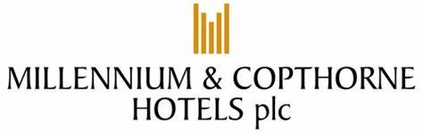

**[Director of Food & Beverage](https://www.linkedin.com/company/83207/)**

#### [Millennium & Copthorne Hotels](https://www.linkedin.com/company/83207/)

#### [Jul 2009 – Apr 2011 ( 1 year 10 months )](https://www.linkedin.com/company/83207/)

#### [Beijing City, China](https://www.linkedin.com/company/83207/)

Best improved performance hotel in Millennium & Copthorne Greater China situated in 3rd Ring road Grand Millennium Beijing. With the support from then Group Director of F&B for Millennium & Copthorne , we managed to overturn total F&B around through drastic efforts in revamping product alignment, pricing strategy & conceptual adjustment both outlets and banqueting



**[Operations Manager to Assistant Director of F&B](https://www.linkedin.com/company/8441/)**

#### [Shangri-La Hotels and Resorts](https://www.linkedin.com/company/8441/)

#### [Mar 2003 – Mar 2008 (5 years 1 month)](https://www.linkedin.com/company/8441/)

Various Locations

Grew with the company known for its check & balance management, revenue driving tactics and financially sound business acumen & productivity driven work culture. Started off as Operations Manager in the prestigious China World Hotel Beijing , relocated to open the 400 seater Yi Cafe of Shangri-la Pudong East followed with a promotion to Assistant Director of F&B in Shangri-la Mactan in Cebu, Philippines. Supported in the luxurious Shangri-la Boracay Flagship Resort opening

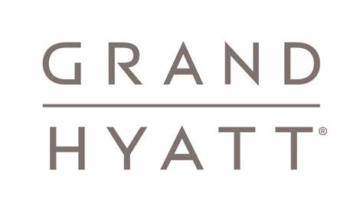

### [Outlet Manager](https://www.linkedin.com/company/2564997/)

#### [Grand Hyatt Singapore](https://www.linkedin.com/company/2564997/)

#### [Jul 1997 – Feb 2003 (5 years 8 months )](https://www.linkedin.com/company/2564997/)

#### [Singapore](https://www.linkedin.com/company/2564997/)

Started my career as Management Trainee with the Hyatt and climb progressively to its benchmark Outlet Manager of mezza9 , with well-equipped foundation in both operational and conceptual skills, brand image, sound F&B knowledge and competencies essential for luxury & upscale hotel management.

**Summary**

In my 21 years I have always been guided by my ***passion for hospitality***. This has led to the respect for time-honored traditions in the industry, such as ‘attention to details’, consistent product , quality driven as well as developing personal creative paradigm shifts to the business. It is truly a business that is governed by both an art and a science.

In terms of ***leadership,*** I am a firm believer of setting clear vision, strategies, tactics and actions for the team. Regardless of the size of the operation this is the key to ensure delivery of quality product and service accurately and consistently 99.9% of the time. With a clear vision the team will eventually internalize the experience we wish to deliver to our guest.

***Financial acumen*** will enable one to ‘crunch’ the numbers of the P&L statements and performance ratios at the end of the financial period leading to corrective measures for the next financial period. However, creating market driven product and services is the key to healthy sustainable revenue to ensure the profitability of the business model.

In terms of ***product differentiation***, we stand to gain if we embrace the local culture and subtly incorporate them into our design, products and service. This would enable each property across a brand to maintain its own distinct flavor.

***Creativity*** enables us to make paradigm shifts in the business of hospitality. Being bold and taking calculated risks will enable us to set the trends as opposed to being mere followers of trends. It is definitely a quality that we should inculcate in the organizations that we work in.

***Due Diligence*** in the science of the hospitality is also essential. Without diligence in the various disciplines that are involved in the management of a hotel can lead us to be prejudiced in our decisions – ‘numbers do not lie’.

The ***fundamentals*** of the core operations in the business of running a full service hotel have not changed over the years. Rooms deliver the bulk of the profit margin and profitable food & beverage creates the awareness of the hotel within the city.

The ***team*** is essential. We must be aware of the seemingly endless list of core disciplines involved in managing our business. It includes, with no intention of being exhaustive, sales & marketing, food & beverage, rooms, revenue management, finance, engineering, MIS, purchasing, cost control and hygiene. Respect each other professionally and be consultative in our approach. This applies to our business ***partners*** as well.

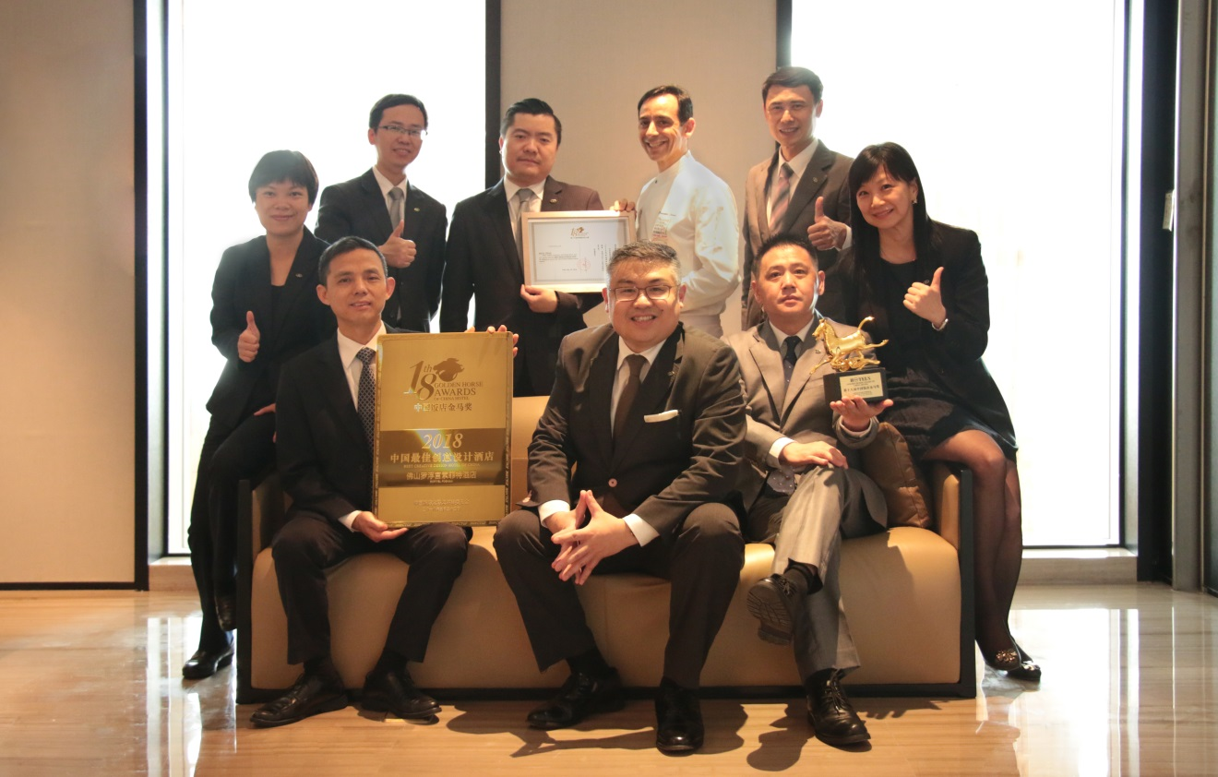

Cultural ***diversity*** is inherent in our business. Our guest and our colleagues hail from diverse backgrounds. A sense of humor sometimes cab be a good ice breaker.

In short it is a business of 60% science and 40% art that requires good leaders at every level of management.

**Character Reference**

**Upon request**