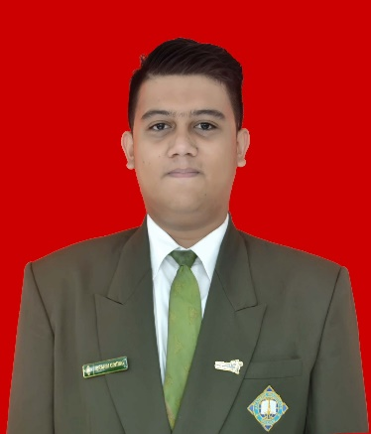
ibrahim

ginting
  - Chef De Partie

Objective  Accomplished & energetic to secure challenging position as Chef De Partie with a solid experience with over 10 years. Proficient in menu development, intermediate cooking skills, food cost and inventory essentials.  Education  MEDAN TOURISM ACADEMY  2013-2016  Diploma III of Culinary Arts Management  contact & Profile  087869700406  ibrahim.gins@gmail.com  Pertanian II Street, Number 115  Lebak Bulus, South Jakarta  Ibrahim Ginting  Jakarta, May 14th 1995  Male  Moslem  Single |  | Experience  CDP AT PT ANIVER KAYA CANTIKA  PRESENT  Oversaw kitchen operations, manage team, collaborated with the team to create menu with F&B policies.  - Develop and create menu and food cost  - Implemented cost-effective inventory management  - Increase guest satisfaction with 4.8 ratings on Shoppe & Google  - Handful for social media administration and create online instant food  - Trained and mentored all team, enhancing their personal skill and improving overall kitchen performance  CDP AT MIYANNA HOTEL MEDAN  2018-2020  Worked with high-pressure culinary environment, responsible for breakfast, a’ la carte, and banquet menu  - Designed and executed a flavorful menu for event and breakfast receiving a good feedback from guest  - Maintained & organized workstation, adhering to food safety and hygiene sanitations  - Collaborated with the F&B team to create a’la carte promo and increase guest satisfaction  COMMIS AT BROS LOUNGE MEDAN  2017-2018  Supported the kitchen team in various sections, ensuring the efficient preparation and presentation dishes.  - Assisted in the preparation of ingredients for daily service  - Contributing innovative ideas  - Manage multiple order simultaneously, ensuring timely & accurate delivery foe customers.

