**Daftar Riwayat Hidup**

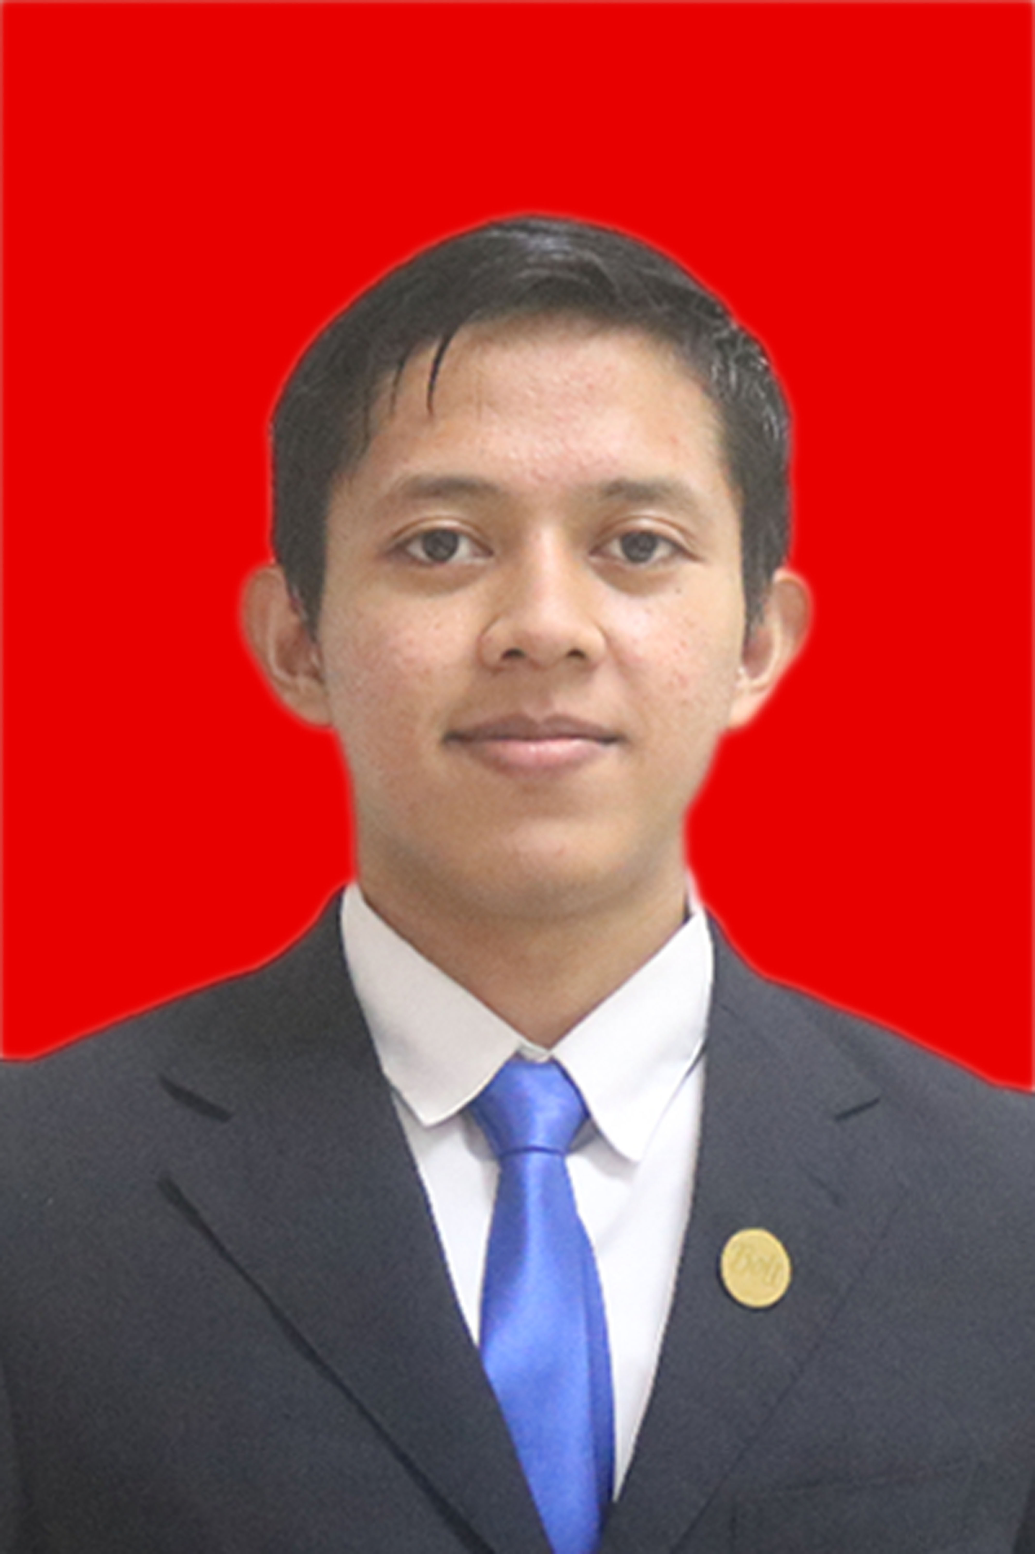

Name : Gandha Vikri Pranata

Address : Jl. Jaha No.49, Cilandak Timur, Jakarta

Social Media Link : www.instagram.com/gandhavp

Mobile Number : 083181371692

Email : vikripranatagandha@gmail.com

**ABOUT YOUR SELF**

A detail-oriented person who have a willingness to learn. I have strong self-principle and values; Professionalism, Integrity, and Humility.

**PERSONAL DETAILS**

Place & Date of Birth : Bukittingi, August 14th 1997

Religion : Islam

Marital status : Single

**EDUCATION**

* STMIK ESQ (Business Information System) 2016 - 2020
* SMK Negeri 12 Bandung (Aviation Electronic) 2013 – 2016
* MTsN Model Padang 2010 - 2013

**WORKING EXPERIENCE**

2020 - Current, Freelancer: IT Support for President ESQ Group at ESQ Leadership Center

2018 - Current, Freelancer: Class Manager at ACT Consulting

2020 - 2021, Freelancer: Personal Assistant at ESQ Leadership Center

2020, Internship: System Developer at PT Tunas Dwipa Matra

2019 - 2020, Freelancer: Web Administrator

2019, Internship: System Developer at PT Angkasa Pura II

2018 - 2019, Part Timer: Coding Instructor at KodeKiddo

2017 - 2018, Vice President Talent Management AIESEC in ESQ BS

**SKILLS**

Power BI, Microsoft Office, Google Office

HTML/CSS, PHP, MySQL, PostgreSQL, Phyton

Video Editing

Swimming

**TRAINING & WORKSHOP**

Basic Organization & Leadership Training

ESQ Training Level 1 - 4

ESQ Training Quantum Excellent

ESQ Training Millionare Mindset

ESQ Grand Power Talk

Sekolah Pasar Modal at ESQ Business School

Penggunaan Agile dan Scrum untuk Development Project

Microsoft Office by Microsoft Philippines

Pembekalan Agent Teman Curhat ID

**PERSONAL INTEREST**

Event Management

Web Development

Stock Market

Sport Activities

Music