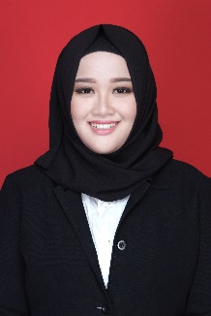**Curriculum Vitae**

|  |  |  |  |  |  |
| --- | --- | --- | --- | --- | --- |
| 1. **IDENTITAS DIRI** | | | | | |
| Nama | **:** | JASMINIA BIRAHMA | | | |
| Jenis kelamin | **:** | Laki-Laki Perempuan (Beri tanda silang sesuai jenis kelamin anda)  × | | | |
| Tempat lahir | **:** | SURABAYA | Tgl. Lahir | **:** | **10 FEBRUARI 1996** |
| Jabatan saat ini | **:** | Staff Pemasaran KCU Kemayoran |  |  |  |
| Email | **:** | [jasminbirahma@gmail.com](mailto:jasminbirahma@gmail.com) // [jasminbirahma.ask@gmail.com](mailto:jasminbirahma.ask@gmail.com) | No. Telp. | **:** | **085 855 299 369** |
| NIP | **:** | 1958.070621 |  |  |  |

|  |  |  |  |  |  |
| --- | --- | --- | --- | --- | --- |
| 1. **RIWAYAT PENDIDIKAN** | | | | | |
| **No.** | **Pendidikan *)** | **Nama Sekolah** | **Kota** | **Fakultas/Jurusan** | **Tahun Lulus** |
| **1** | 2014-2019 | Universitas Brawijaya | Malang | MIPA / Statistika | 2019 |
| **2** |  |  |  |  |  |
| **3** |  |  |  |  |  |
| **4** |  |  |  |  |  |

| 1. **RIWAYAT PEKERJAAN** | | | | |
| --- | --- | --- | --- | --- |
| **Periode**  **Tahun** | **Nama Instansi** | **Divisi/ Branch/ Dept.** | **Jabatan** | **Kota** |
| 2020 | PT. Wahana Gumilang | Penjualan | Staff Penjualan | Surabaya |
| 2021-Sekarang | PT Asuransi Kredit Indonesia | Marketing | Staff Pemasaran | Jakarta |
|  |  |  |  |  |
|  |  |  |  |  |
|  |  |  |  |  |
|  |  |  |  |  |