**CURRICULUM VITAE**

Personal Information

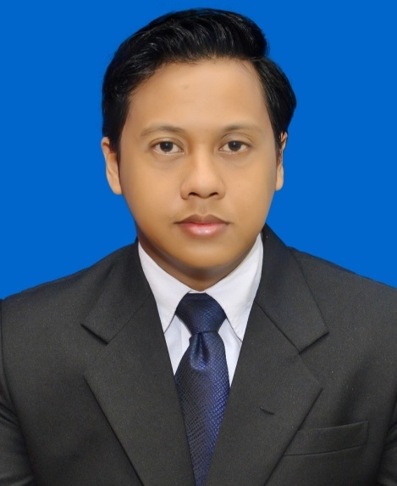

Name : Okky Adityaswara

Home Adress : Jln Kutilang VI Blok L1 No 14, Bintaro Jaya sektor 2. South Tangerang

Born : October 27th, 1991. In Medan

Citizenship : Indonesia

Marital Status : Single

Email : okky.adityaswara@gmail.com

Phone : +62812-1433-0331

Education

Bachelor of Social Welfare GPA :3,25 (Scale 4.0)

Faculty of Social Science and Political Science, padjadjaran University, Bandung

Non Formal

English language course LBPP LIA Intermediate

Work History

March 2014 – August 2015

PT Sinergi Mitra Proteksindo (insurance Broker)

Staff Administration Insurance Claim

* Preapare all necessary document related insurance claims
* Documentating all incoming claims
* Ensure Claims are in the limit, and in accordance with the requirementes of the policy

January 2nd 2017 – January 5th 2018

PT. Asuransi Jiwa Generali Indonesia.

Marketing Business Renewall Employee Benefit Product

* Analyze data claim & data member
* Make a report and presentation for client
* Assist client administratively in terms of renewal policy
* Provide Upselling
* Designing benefit and analyzing renewal proposal
* Handle complain client

March 12th 2018 – Now

PT. Asuransi Kredit Indonesia (Persero).

Supervisor Underwriter Askrindo Branch Tarakan

* Analyze of Surety Bonds Products
* Coordinate with Partners Bank if there has surety Bond Closing involve a Partner Bank
* Administrative work